The Botswana camps in the Kgalagadi & Kaa Concession area

In September, 2016 we decided to set off in our 4x4s and explore the Northern Botswana camps in the Kgalagadi Transfrontier Park (not Mabuasehube in the east), and then on into the Kaa Concession area further north.
No rain had fallen since March, so the whole of the Kgalagadi and the Kaa Concession area were very, very dry, with no water in the pans other than where a trough had been built and water pumped in.

Our planned route would take us to the following Botswana campsites:
- Rooiputs S26º 19’ 44.1” E20º 44’ 19.3”
- Polentswa S25º 05’ 14.0” E20º 25’ 39.5”
- Sesatswe (on the Polentswa trail) S24º 32’ 10.5” E20º 49’ 13.8”
- via Sizatswe camp as a lunch stop to S24º 22’ 33.5” E20º 20’ 48.4”
- Swartpan 1 S24º 13’ 52.4” E20º 01’ 08.2”
- Gnu Gnus S24º 36’ 57.5” E20º 14’ 51.4”
- Thupapedi S24º 24’ 19.0” E20º 21’ 11.1”

Our plan was then to exit the reserve at the Kaa gate in the very north of the park and head for some destinations in the Kaa Concession area, viz.
- Zutshwa S24º 08’ 10.8” E21º 15’ 33.2”
- Masetleng pan S23º 42’ 20.7” E20º 53’ 55.1”
- Hukuntsi (for fuel) S23º 59’ 56.2” E20º 46’ 47.6”

And then back home via Kang.

We set off from Johannesburg and overnighted at Leeupan (S26º 57’ 02.8” E21º 52’ 11.2”), about 22 kms west of VanZylsRus, and 724 kms from Johannesburg. It was in this area that the TV series “Meerkat Manor” was filmed.

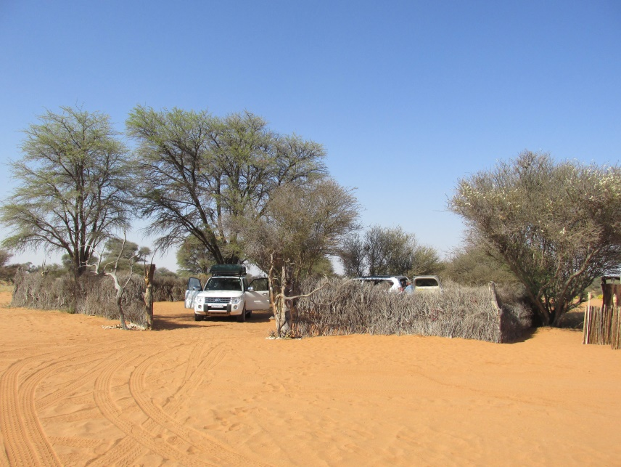
Leeupan campsite

The next morning we backtracked 13kms to the Middelputs border turnoff and entered Botswana at Middelputs. The road to Twee Rivieren (or actually “Two Rivers” as it’s called on the Botswana side (same entrance building, though)) was mostly tarred - the last stretch was a good gravel road to the entrance to the Park.
After refuelling we set off for Rooiputs, some 26kms north of Twee Rivieren.

Rooiputs
Rooiputs has 6 campsites (and a lodge about 1km before the camp sites).
Each campsite consists of a tree (or two), a circular reeded shelter housing a longdrop toilet, another circular shelter housing a metal frame (like a high doorframe) from which you can hang your solar shower bag, an A-frame shelter for shade, and a tap above a wash basin. The water, however, is so salty that it is undrinkable, so we used it just for washing. All the campsites are much the same, other than campsite 5, which is situated under a huge water tank and has no ablution or shower facilities of its own (one shares with campsite 6, although 6’s ablutions are about 70 metres from the no. 5 campsite, so this doesn’t happen in practice).

In the evening one is surrounded by barking gekkos all barking their hearts out (they do go to bed later). We spent 3 nights in Rooiputs, going for game drives during the day, or just chilling out around the camp.

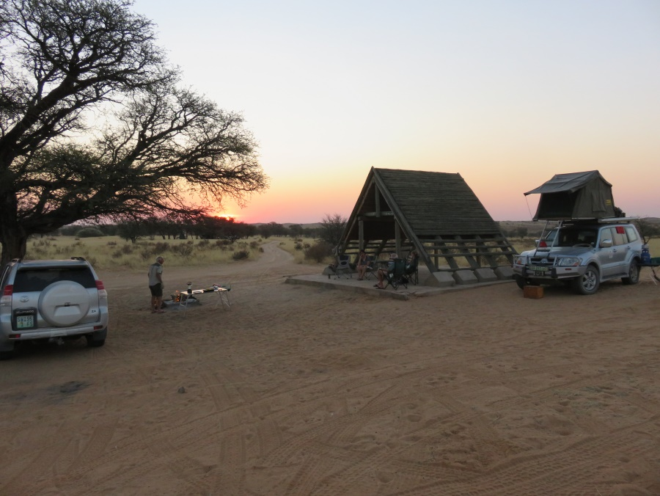
Rooiputs campsite 6

At the end of our stay we saddled up and headed north on the renowned seriously corrugated road to Nossob, where we again refuelled and carried on the extra 60kms to Polentswa.
We were looking forward to this, as Polentswa is extremely difficult to get into, and we were expecting something really special.

Polentswa
Polentswa has the same layout as Rooiputs, but only 3 campsites AND NO FACILITY FOR WATER!
This caught us a bit off-guard, so the next day some of the party braved the road back to Nossob to buy water (which came in 5 litre plastic bottles).
The new Polentswa lodge is about 4kms further on.
We found out later on, from other campers who had camped in campsite 2 (as we did) that it had a resident Cape cobra and an aggressive deadly poisonous scorpion. Luckily we came across neither.

On the first night we were visited by lion, but only picked this up the next morning when we saw the spoor in our camp, although we had heard the roaring during the night.

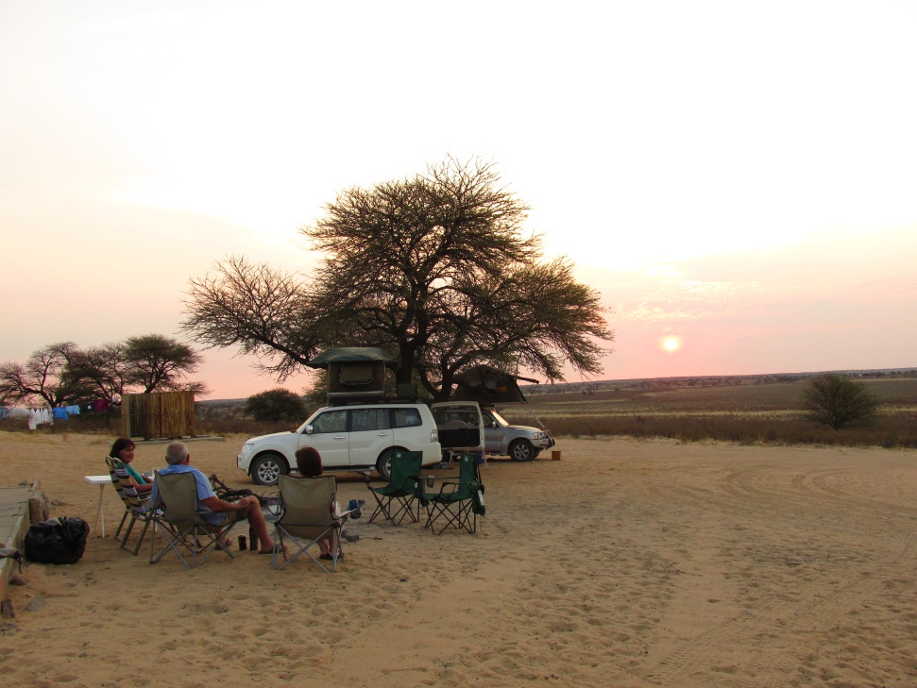
Polentswa camp 2

After 3 nights at Polentswa camp 2 we set out to brave the Gemsbok Wilderness Trail (also known as the Polentswa Trail).
This trail starts at the Polentswa camps (you actually drive past the campsites). About 3 kms past the campsites the road forks. The right-hand fork takes you to the new Polentswa Lodge, and the left-hand fork is the trail. The trail takes you north almost as far as Kaa gate to a campsite called Sesatswe, where one has to overnight before proceeding on the 2nd leg of the trail which takes you down again to Lang Rambuka, not far from Polentswa, where one is obliged to spend the 2nd night.
Each leg is about 109kms on a very sandy “Jeep” track.

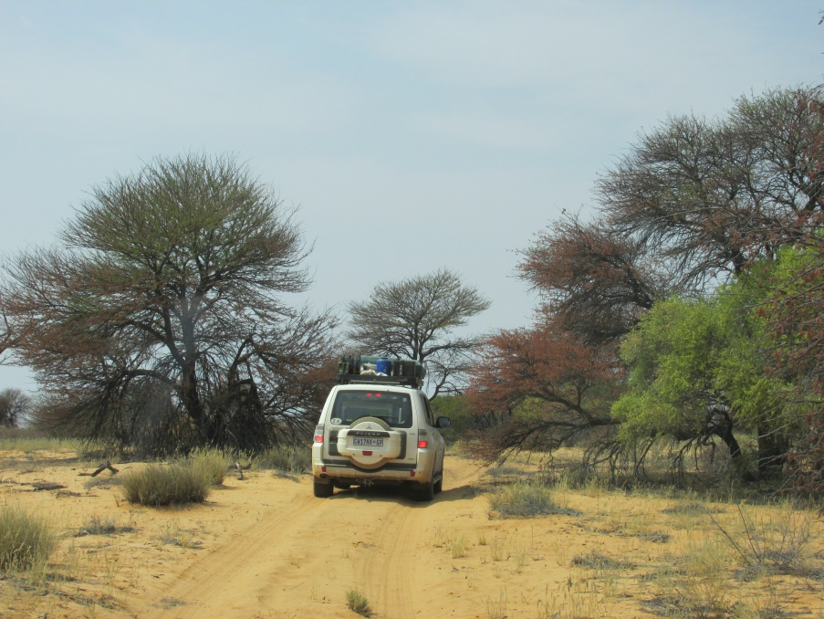
Polentswa trail

We decided, once at Sesatswe, to risk spending two nights there and foregoing the downward leg to Lang Rambuka, both because, after Lang Rambuka, we had to come back up to the Kaa gate on our way to Swartpan in the north-west and, on the upward Sesatswe leg, we had consumed far more fuel than we had anticipated because of the thick sand. We would not have enough fuel to do the rest of the Botswana camps. Fortunately the Botswana camps were quiet, and we were able to spend the extra night there. As a result we never got to see Lang Rambuka camp.

Sesatswe
There are no facilities at this campsite, but I would rank it as one of the best campsites in the Botswana Kgalagadi. Plenty of shade and a nice camping area. We were very happy to spend two nights there instead of moving on the Lang Rambuka. It’s a pity that, in season, one would probably have to obey the rules and move on after one night to allow for the next visitor.
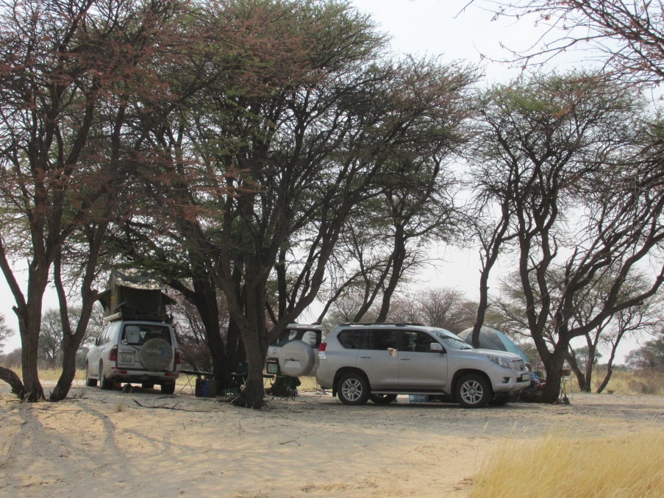
Sesatswe campsite

The next campsite on our list was Swartpan, the most north-westerly Botswana camp in the Kgalagadi. Our route from Sesatswe would take us past the Kaa gate (where we could dump our rubbish) and on to Swartpan.
To our delight the Kaa gate guards advised us that Swartpan had water, so there was no need to fill up at one of the gate campsites.

The road (jeep track) to Swartpan was lined with dry bushes, and as a result our cars got fairly badly scratched. On the way we popped into Sizatswe camp for a lunch stop.

Sizatswe
This is a small campsite with one tree and no facilities.
It really is just suitable for one vehicle, and doesn’t offer anything special.

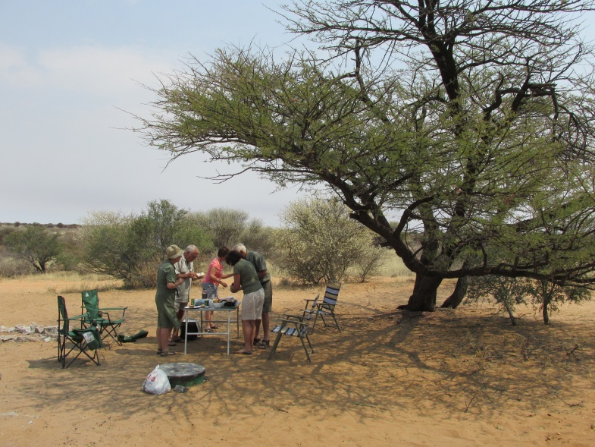
Sizatswe

After a brief lunch (and a beer or two) we moved on and were rewarded on arrival at Swartpan with a view of a large pan and, at the campsite end, a man-made water trough covered in vultures! What a sight! This boded well for our stay at Swartpan 1.

Swartpan
There are two campsites at Swartpan, Swartpan 1 and Swartpan 2.
Swartpan 1 is closest to the pan, Swartpan 2 is about 300 metres further on. Both boast lovely campsites with big trees.
Swartpan 1 has a tap, but no water. Swartpan 2 has a tap with drinkable water. (We pointed out the fact that the Swatpan 1 tap was dry to the park officials at Kaa gate on our return and they shrugged and said “yes, it is blocked”). We stayed at Swartpan 1 and collected water from the tap at Swartpan 2
Of all the campsites in the Botswana Kgalagadi, this was our favourite.
At night we were visited by lions which took up residency in our camp for a few hours, keeping us tent-bound.
On the second day a large lioness walked into our camp, looked at us, turned round and limped off. She obviously had injured her foot, and that possibly what made her decide to turn around, much to our relief!
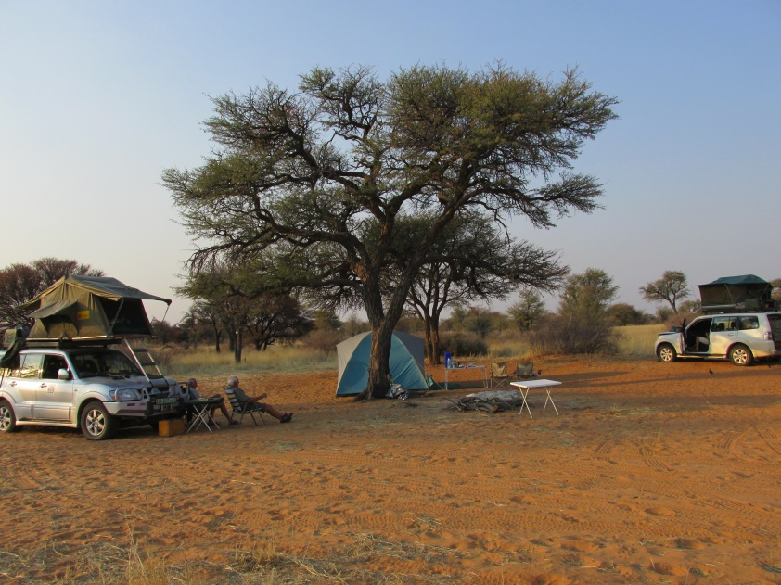
Swartpan camp 1

We stayed at Swartpan for two nights and then, on the third day, moved on to our next stop, Gnu Gnus, some 55kms south of Swartpan.

Gnu Gnus
As a campsite, this was a disaster. It was most unappealing and lacked shade.
If you go to the Botswana campsites, give this one a miss.
So bad was it that we decided to forgo the camp fees and move straight on to our next stop, Thupapedi (some 30kms further), trusting that there would be nobody there, and not knowing what we would find.
We were lucky, the place was deserted and the campsite a very pleasant surprise!

Thupapedi
Thupapedi is a large, treed campsite. There are no facilities, but the camping area is nice.
We rated this as one of the better campsites in Botswana Kgalagadi, along with Swartpan & Sesatswe.

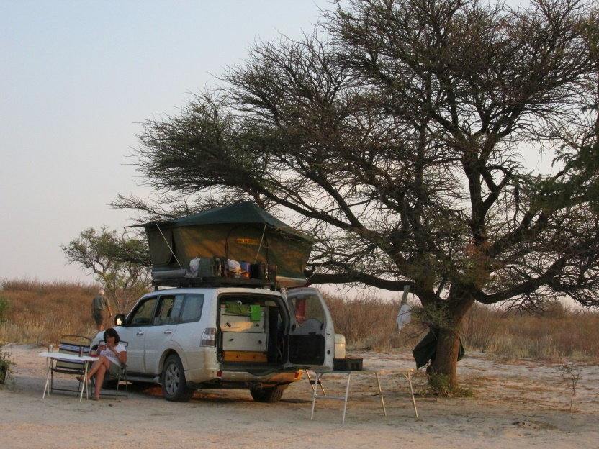
Thupapedi

After two nights at Thupapedi we headed north to explore the Kaa Concession area.
On checking out at Kaa gate and mentioning to the ranger our plan to go camping at Masetleng pan for a couple of nights, he advised that we would have to get a permit for this, and that this must be got a Zutshwa. This was contrary to the information in Mike Main’s (and Veronica Roodt’s) books that cited Ngwantle village (much closer to Masetleng pan) as the place to get the permit. So we headed for Zutshwa.

A few hundred meters after leaving the Kaa gate the road forked, and a signboard at the fork indicated that the left-hand road was the “Transit” road to Zutshwa, and the right-hand road the “Scenic” road to Zutshwa, (actually just a Jeep track) some 30kms shorter. This “Scenic” road used to be part of a hunting concession and out of bounds to normal mortals like us, but, as Botswana had scrapped all hunting, this was now available. We decided to take the “Scenic” Jeep track, which turned out to be very sandy, very bumpy, and very scratchy, but we did pass herds of antelope.

We finally arrived in Zutshwa, just a small dusty village (almost no cars that we could see) with, believe it or not, stop signs at a couple of ill-defined dirt crossroads.

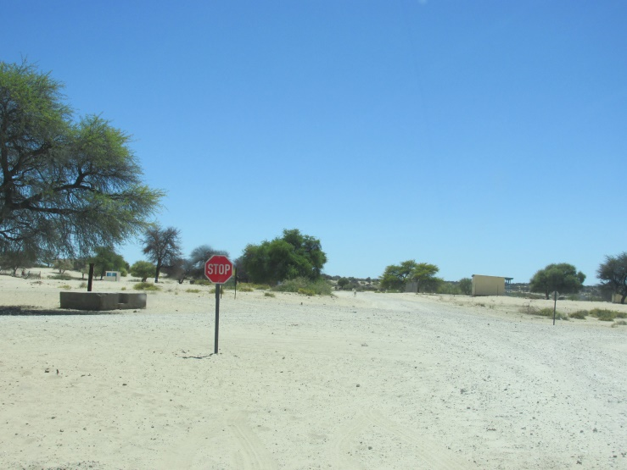
Zutshwa stop street

And there, on the side of the road, was an old green sign bearing an arrow pointing the way to the permit office. On we went, and after a few hundred yards came to a second sign bearing an arrow pointing the way to the permit office. But where the actual permit office was, was anyone’s guess! After looking around and asking some locals where the permit office was (they had never heard of a permit office), we decided to give up and head for Ngwantle as advised in the books we had read and get the permit there.

The dirt road out of Zutshwa all the way to Ngwantle was in good condition, so we pumped up our tyres and made good time to Ngwantle, the hop-off point to Masetleng pan.
At the one & only crossroads in the little village we asked some locals where the permit office was. They said there was a lady who issued permits, but she was not at home and they didn’t know where she was or when she would be back. So we decided to move on through the village and head for the pan following our GPS’s, and pay for our stay on the way back. The road to Masetleng pan was in fact just a Jeep track that had not been used for some time, and was bordered by bushes which we were unable to avoid had had to grit our teeth every time the car was scratched.

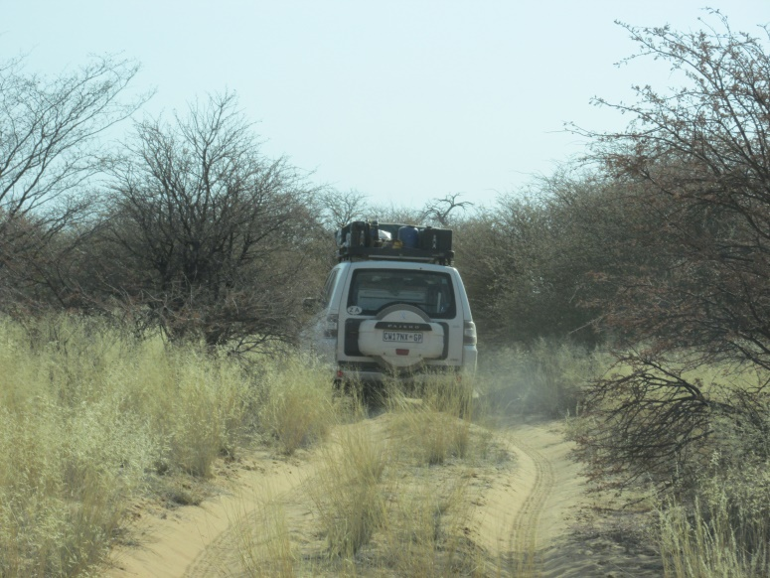
Road to Masetleng Pan

Masetleng pan and its surrounds are described by Mike Main in his book “African Adventurer’s Guide To Botswana” as “one of the most beautiful places I have seen in Botswana”, so we were keen to go and have a look. Unfortunately, we were there at the wrong time (20th September) as no rain had fallen for months, and the acacias had not yet come into leaf and everything was looking decidedly dry and bleak. But looking through this we could see that it would indeed be very beautiful in summer after the rains.
At this point in our journey the weather turned cold with a bitter south wind blowing and absolutely freezing at night, so we decided to call it quits and head for home, refuelling at Hukuntsi on the way home via Kang and the Ramatlabama border just outside Mahikeng.

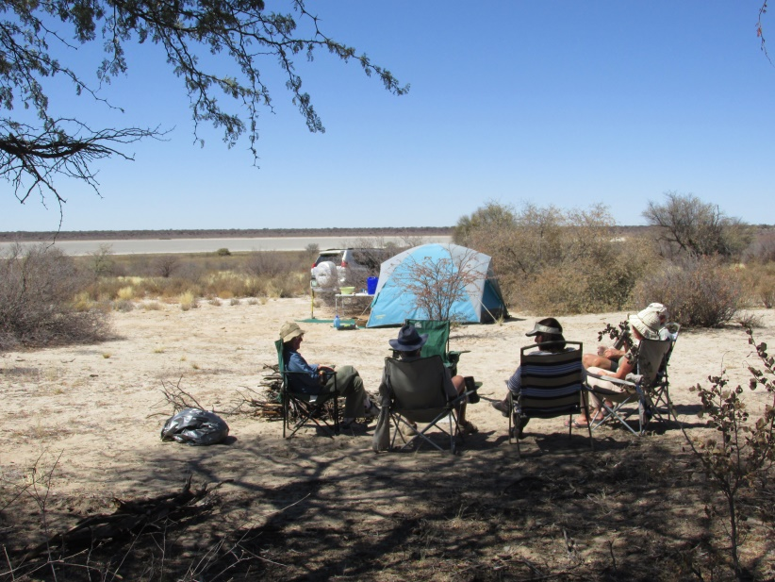
Campsite at Masetleng pan

Booking & cost of the Kgalagadi Botswana camps.

Booking can be made on the website dwnp@gov.bw
Costs for non-residents are as follows:
Camp fees P30/night/person
Park fees P20/night/person
Car fees P4/car/day
Polentswa trail fees P400/person (which includes the camp fees for Sesatswe & Lang Rambuka)

